______________________________________________________________

UM-SJTU JOINT INSTITUTE

INTRO TO CIRCUITS

(VE 215)

______________________________________________________________

LABORATORY REPORT

LAB 1

DC LAB

|  |  |  |
| --- | --- | --- |
| Name: **Weikai Zhou** | ID: **518021911039** |  |
| Name: Fan Chen | ID: 518021910739 |  |
| Date: 22 October 2019 |  |  |

1. **Introduction [1]**
   1. **Objectives**

* Learn how to use UT60A multimeter to measure voltage, current, and resistance
* Learn how to build circuits on a solderless prototype board
* Verify the basic circuit laws-KCL, KVL, and Ohm’s laws based on the measurements of currents and voltages
* Measure the current-voltage characteristics of a 50 $Ω$ resistor and try to verify that whether they obey the Ohm’s law based on the results of measurements
* Build an LED circuit on a protoboard and learn about non-ohmic circuit components, which do not obey Ohm’s law
  1. **Apparatus & Theoretical background**
     1. **Multimeter**

A multimeter can work as a voltmeter to measure voltages, as an ammeter to measure currents, or as an ohmmeter to measure resistances. Every multimeter has two terminals for the two cables that ensure electrical connections to the two nodes. The black cable should be connected to ground, the ground port is labeled COM on the multimeter. The red cable should be connected to HzVΩ port for voltage or resistance measurements, 10A MAX port for current measurements, or *µ*AmA port for small current measurements.

For voltage measurement, we need to know that voltmeter has its own internal resistance, which is very high. And an ideal voltmeter has infinitely large internal resistance. In real cases, they usually exceed 1 M $Ω$. When we measure $V_{AB}$, the voltmeter’s internal resistance is connected in parallel with all circuit elements between these two terminals. So, we do not need to change any thing of our circuit and just connect it to the nodes of interest.

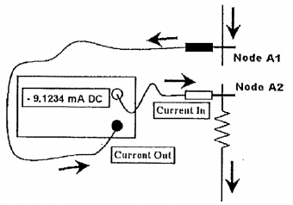For current measurement, we should make the current flow through the multimeter. Therefore, we need to interrupt the circuit to measure the current. Figure 1 shows how it works.

Figure 1. The multimeter

For resisance measurements, first, we must disconnect the resistor form the circuit before measuring the resistance. Then we can simply connect it to the two terminals of the multimeter and read the resistance from the display.

* + 1. **DC source**

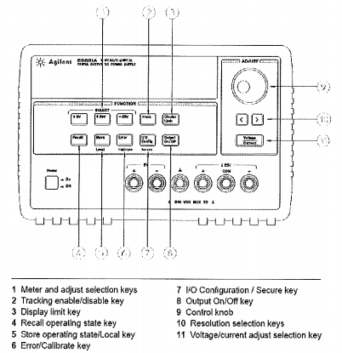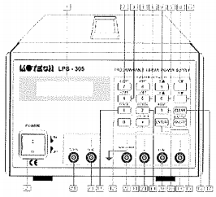There are two kinds of power supply. The first one is MOTRCH LPS 305 Power Supply (Figure 2 [2]) and the second one is Agilent E3631A DC Power Supply (Figure 3 [3]).

Figure 2. MOTRCH LPS 305 Power Supply Figure 3. Agilent E3631A DC Power Supply

To set up the first one,

(1). When we press the +Vset, or -Vset, the output selected (+output or -output) and the present setting for that function will be displayed. We can change setting using the numeric entry keys. Pressing the number keys will cause the present numeric setting to become blank and be replaced with the new numbers on the display. Pressing the ENTER key will enter the values displayed.

(2). The selected output channel can be turned on and off from the front panel. The outout on/off key toggles both the +output and -output on and off simultaneously.

(3). We should remember to turn off the output when there is no measurements are being undertaken.

To set up the second one,

(1). We should connect a load to the desired output terminals with power-off.

(2). We should press to turn on the power supply. The power supply then goes into the power-on / reset state; all outputs are disabled (the OFF annunciator turned on); the display is selected for the +6V supply (the +6V annunciator turns on); and the knob is selected for voltage control.

(3). We should adjust the knob for the desired output voltage. Then we set the knob for voltage control. The second digit of the voltmeter will be blinking then. We adjust the knob to the desired output voltage.

* + 1. **Protoboards**

We connected resistors, LEDs and other components to each other on a circuit board. Circuits boards are also known as “protoboards”, “breadboard”, or “solderless prototyping boards”, because they are used for prototyping the circuits. With the help of it, we can build circuit without soldering every connection.

A prototyping board used in the lab consists of several plastic blocks. These plastic blocks are mounted on a metal plate along with terminal (blind) posts.

Each plastic block has many holes, into which we insert wires, plug in resistors, op amps, and other circuit components. Inside the plastic block, themetal clips snugly hold our wires, resistors, etc., and ensure electric connections between circuit components.

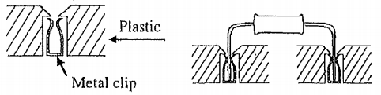The metal clips (Figure 4) hidden under the plastic create nodes on the protoboard, to which we connect our circuit components.

Figure 4. Metal clips

Connections under the plastic are different for the wide and narrow blocks. Straight lines on Figure 5 below show the metal clips that connect holes under the plastic.

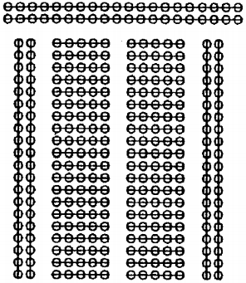Figure 5. Connections under the plastic

* + 1. **Semiconductor diodes**

The simplest semiconductor device is a diode (Figure 6). Its circuit symbol looks like an arrow because the diode allows the current flow only in the direction of that arrow. If $V_{A}>V_{B}$ (which is called direct bias) the conductor will conduct. If $V_{A}<V_{B}$ (which is called reverse bias) the conductor will not conduct. Thus, a diode is not an Ohmic resistor.

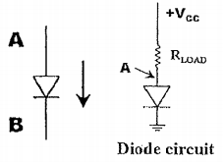Figure 6. Semiconductor diodes

Moreover, even under direct bias the resistance of a diode does not remain constant. At small values of the voltage difference $V_{A}-V_{B}$, the current through the diode is very small, because its resistance is large. The diode’s resistance abruptly changes as soon as the direct bias voltage across the diode reaches the threshold value, which is called the turn-on voltage and equals about 0.5 to 0.7V for many diodes. Above this voltage the current through the diode rapidly increases and becomes practically independent of the voltage. The diode resistance becomes so small that in real circuits the diodes have to be protected from high currents that may damage them. A load resistor (50Ω in this lab) connected in series with the diode ensures the simplest protection. Light-emitting diodes emit light (visible or infrared) when the direct current becomes large enough. The LED, which we will use in this lab, has the turn-on voltage of about 1.6V.

1. **Measurements [1]**
   1. **Voltage, current & resistance measurement**
      1. We should use the multimeter to measure the resistance R1 labeled 100Ω directly and record the result.
      2. We should connect the resistance R1 = 100Ω with the power supply and set the voltage 3V.
      3. We should use the multimeter to measure the Voltage (m) across the resistor and compare it with the Voltage (s) shown on the power supply.
      4. We should use the multimeter to measure the Current (m) through the resistor and compare it with the Current (s) shown on the power supply.
   2. **Voltage division & current division**
      1. Before measurement, we should measure the actual resistances of the two resistors we are using in this section.
      2. We should connect the R1 = 100Ω and R2 = 50Ω in series and in parallel, respectively.
      3. We should use the multimeter to measure the voltage across the R1, R2 and the power supply, and think about the relationship among the three voltages.
      4. We should use the multimeter to measure the current through R1, R2 and the power supply, and think about the relationship among the three currents.
      5. We should compare the result with what we expect.
   3. **Ohm’s law**
      1. We should measure the resistance of R = 50Ω and record the result.
      2. We should connect the R with the power supply.
      3. We should set the voltage outputs and record the corresponding currents.
      4. We should sketch the voltage-current characteristic curve of the resistor.
   4. **Non-ohmic LED**
      1. We should connect the resistor R = 50Ω and the LED in series with the power supply.
      2. We should change the voltage output and record the corresponding current.
      3. We should design the proper step of voltages to get the voltage-current characteristic of the non-ohmic device.
2. **Results & discussion [4]**
   1. **Voltage, current & resistance measurement**

According to 2.1., we get Table 1 for measurement of voltage, current, and resistance as shown below.

|  |  |  |  |
| --- | --- | --- | --- |
| Resistance [$Ω$] | 99.5 | | |
| Voltage (m) [V] | 2.998 | Voltage (s) [V] | 2.99 |
| Current (m) [A] | 0.029 | Current (s) [A] | 0.027 |

Table 1. Measurement of voltage, current, and resistance

Based on the results presented in Table 1, we can calculate the relative error of resistance measurement:

* 1. **Voltage division & current division**

According to 2.2., we get Table 2 for measurement of voltage division and current division as shown below.

|  |  |  |  |  |  |  |  |
| --- | --- | --- | --- | --- | --- | --- | --- |
| Resistance R1 [$Ω$] | | 99.5 | | Resistance R2 [$Ω$] | | 46.9 | |
|  | Voltage division | | | | Current division | | |
| Current [A] | | Voltage [V] | | Current [A] | | Voltage [V] |
| Total | 0.020 | | 3.000 | | 0.081 | | 2.992 |
| R1 | 0.020 | | 2.038 | | 0.029 | | 2.991 |
| R2 | 0.020 | | 0.959 | | 0.052 | | 2.990 |

Table 2. Measurement of voltage division and current division

Based on the results presented in Table 1, we can see that our results match the KCL and KVL theorem because for voltage division:

$\left\{\begin{aligned}I_{total}=I_{R1}=I_{R2} \\ V_{R1}+V_{R2}=2.997V≈V_{total}\end{aligned}\right.$,

and for current division:

$\left\{\begin{aligned}I_{R1}+I_{R2}=0.081V=I_{total} \\ V_{total} ≈V_{R1} ≈V_{R2}\end{aligned}\right.$.

The relative errors are

,

and

.

* 1. **Ohm’s law**

According to 2.3., we get Table 3 for measurement of voltage and current for Ohm’s law as shown below.

|  |  |
| --- | --- |
| Resistance [$Ω$] | 46.9 |
| Voltage [V] | Current [A] |
| 0.5 | 0.009 |
| 1.0 | 0.020 |
| 1.5 | 0.031 |
| 2.0 | 0.041 |
| 3.0 | 0.063 |
| 4.0 | 0.086 |
| 5.0 | 0.108 |

Table 3. Measurement of voltage and current for Ohm’s law

Based on the results presented in Table 3, we can use Origin to apply liner fit, as shown in Figure 7.

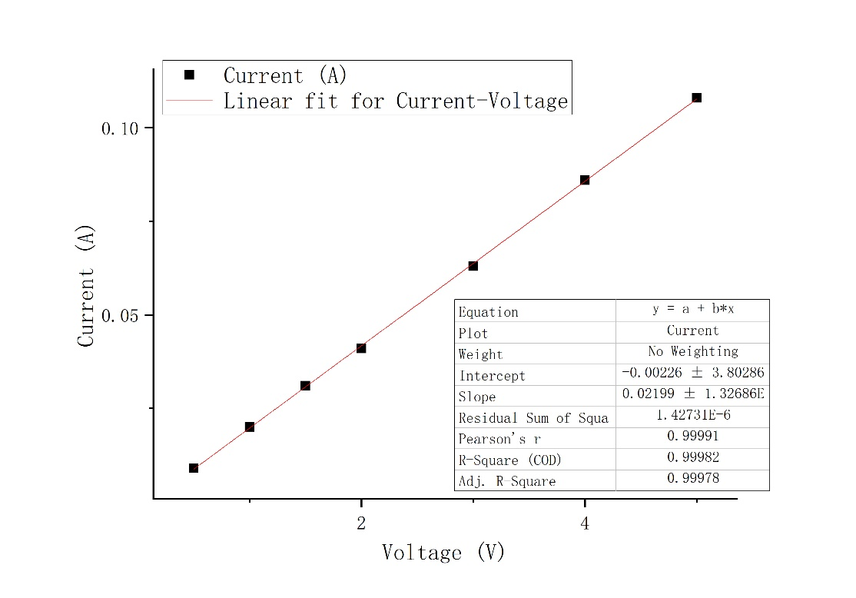Figure 7. Linear fit for current-voltage

From Figure 7, we can see that $R^{2}$ =0.99982 and Pearson’s r = 0.99991, which are both close to 1. Therefore, we can conclude that this resistor obeys the Ohm’s law.

* 1. **Non-ohmic LED**

According to 2.4., we get Table 4 for measurement of voltage and current for non-ohmic LED as shown below.

|  |  |
| --- | --- |
| Voltage [V] | Current [A] |
| 1.0 | 0.0000 |
| 2.0 | 0.0025 |
| 3.0 | 0.0173 |
| 4.0 | 0.0352 |
| 5.0 | 0.0521 |
| 6.0 | 0.0728 |

Table 4. Measurement of voltage and current for non-ohmic LED

Based on the results presented in Table 4, we can calculate the voltage on the LED.

Table 5. Calculated voltage and current for non-ohmic LED

|  |  |
| --- | --- |
| Voltage [V] | Current [A] |
| 1.000 | 0.0000 |
| 1.883 | 0.0025 |
| 2.189 | 0.0173 |
| 2.349 | 0.0352 |
| 2.557 | 0.0521 |
| 2.586 | 0.0728 |

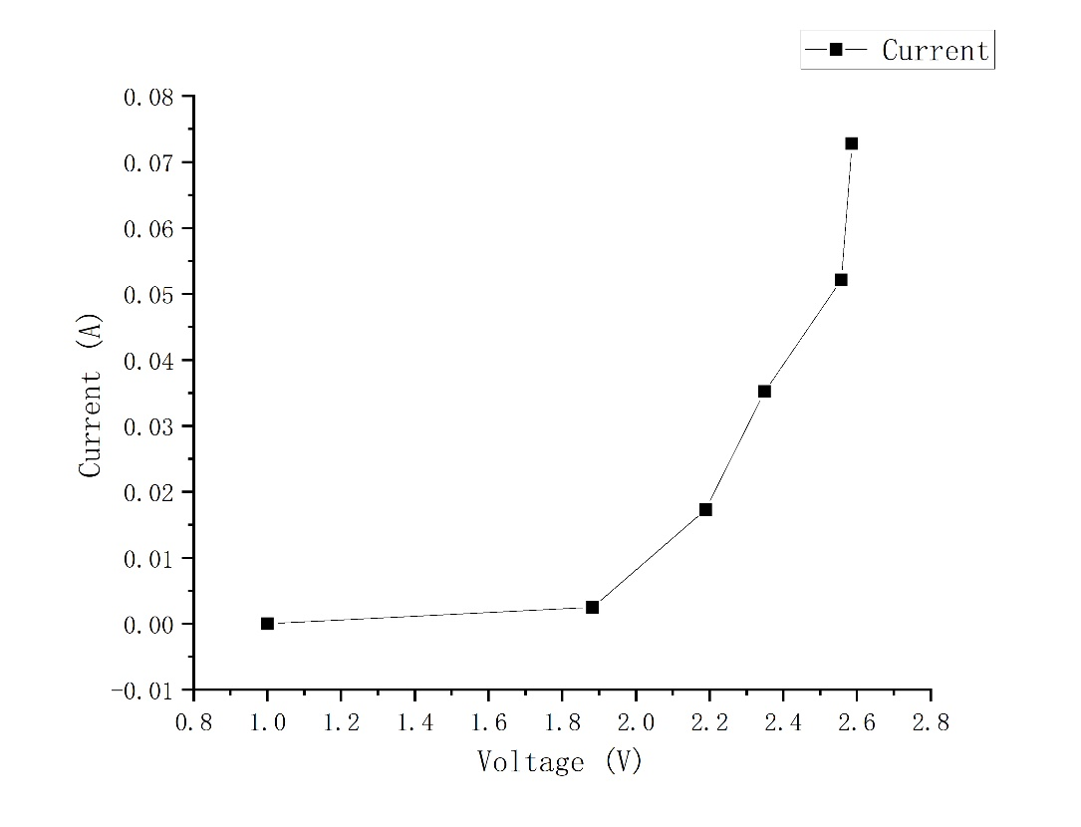Figure 8. Current-voltage characteristic curve for non-ohmic LED

From Figure 8, we can find that the graph corresponds to the description of a semiconductor diode. Moreover, we may also conclude that the turn-on voltage is between 1.000~1.883 V, as expected in 1.2.4.. But we can do more experiment between them to get a more accurate value.

1. **Conclusions [1][4]**

In the experiment, we learn how to use UT60A multimeter to measure voltage, current, and resistance, learn how to build circuits on a solderless prototype board, verify the basic circuit laws-KCL, KVL, and Ohm’s laws based on the measurements of currents and voltages, measure the current-voltage characteristics of a 50 $Ω$ resistor and try to verify that whether they obey the Ohm’s law based on the results of measurements, and build an LED circuit on a protoboard and learn about non-ohmic circuit components, which do not obey Ohm’s law. All the objectives have been achieved. Therefore, the experiment is quite successful.

During the experiment, we also find something that will affect the accuracy of the experiment. For example, in the part “Voltage, current & resistance measurement”, we find that although we have set the output of the power supply to be 3.00 V, it can actually only provide 2.99 V, which is displayed by the power supply.

Moreover, since the multimeter is not ideal, there are internal resistance when we measure the current and the internal resistance is not infinitely large when we measure the voltage and the life of the battery can also influence the measurement of the resistance. Besides, there is also internal resistance for the wires and protoboard.

In order to improve the accuracy of our experiment, we can use better equipment and change a new battery for the multimeter to increase its accuracy. Moreover, we have to insert the wires into the protoboard well to guarantee a better contact.

1. **References**

[1] Lab 1_DC Lab_Manual.pdf

[2] Retrieved from <http://www.motech.com.tw/>

[3] Retrieved from <http://cp.literature.agilent.com>

[4] VE215_Sample_Report